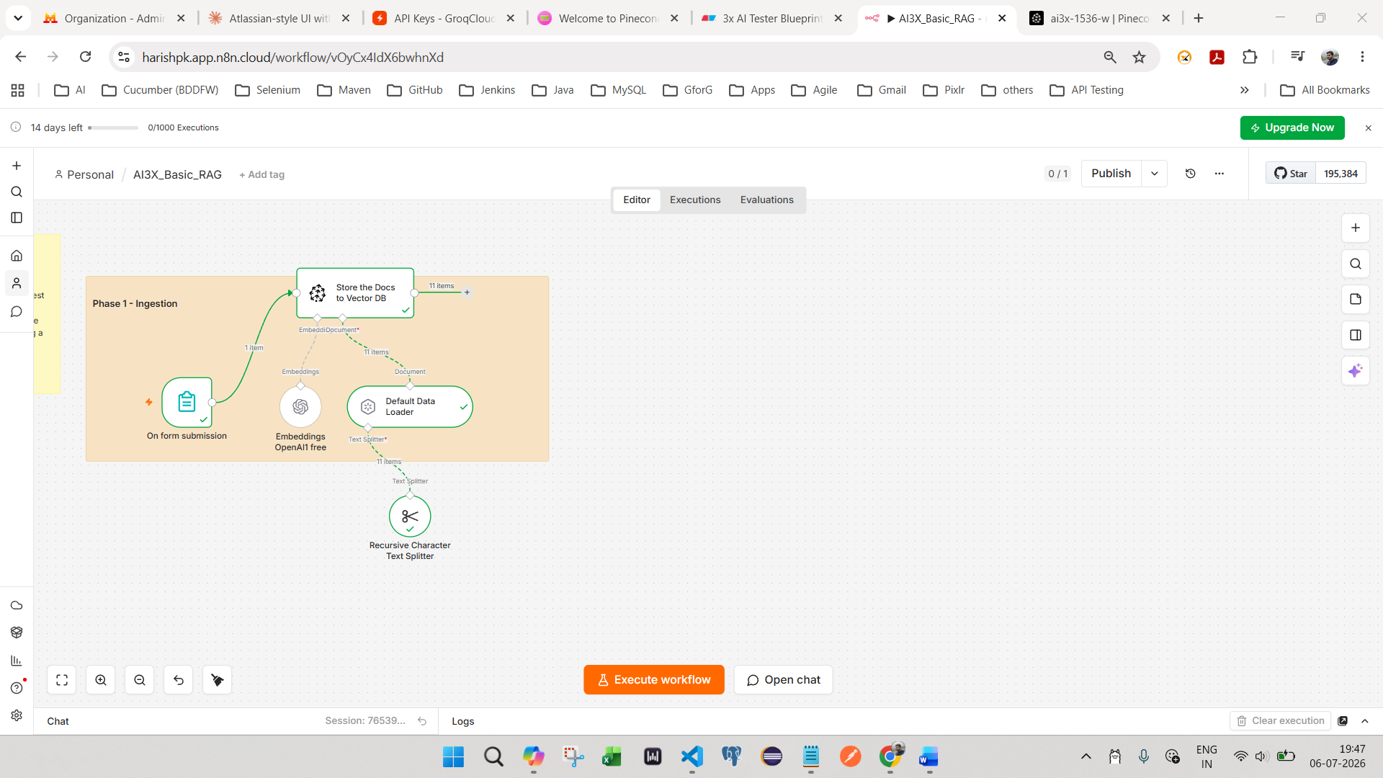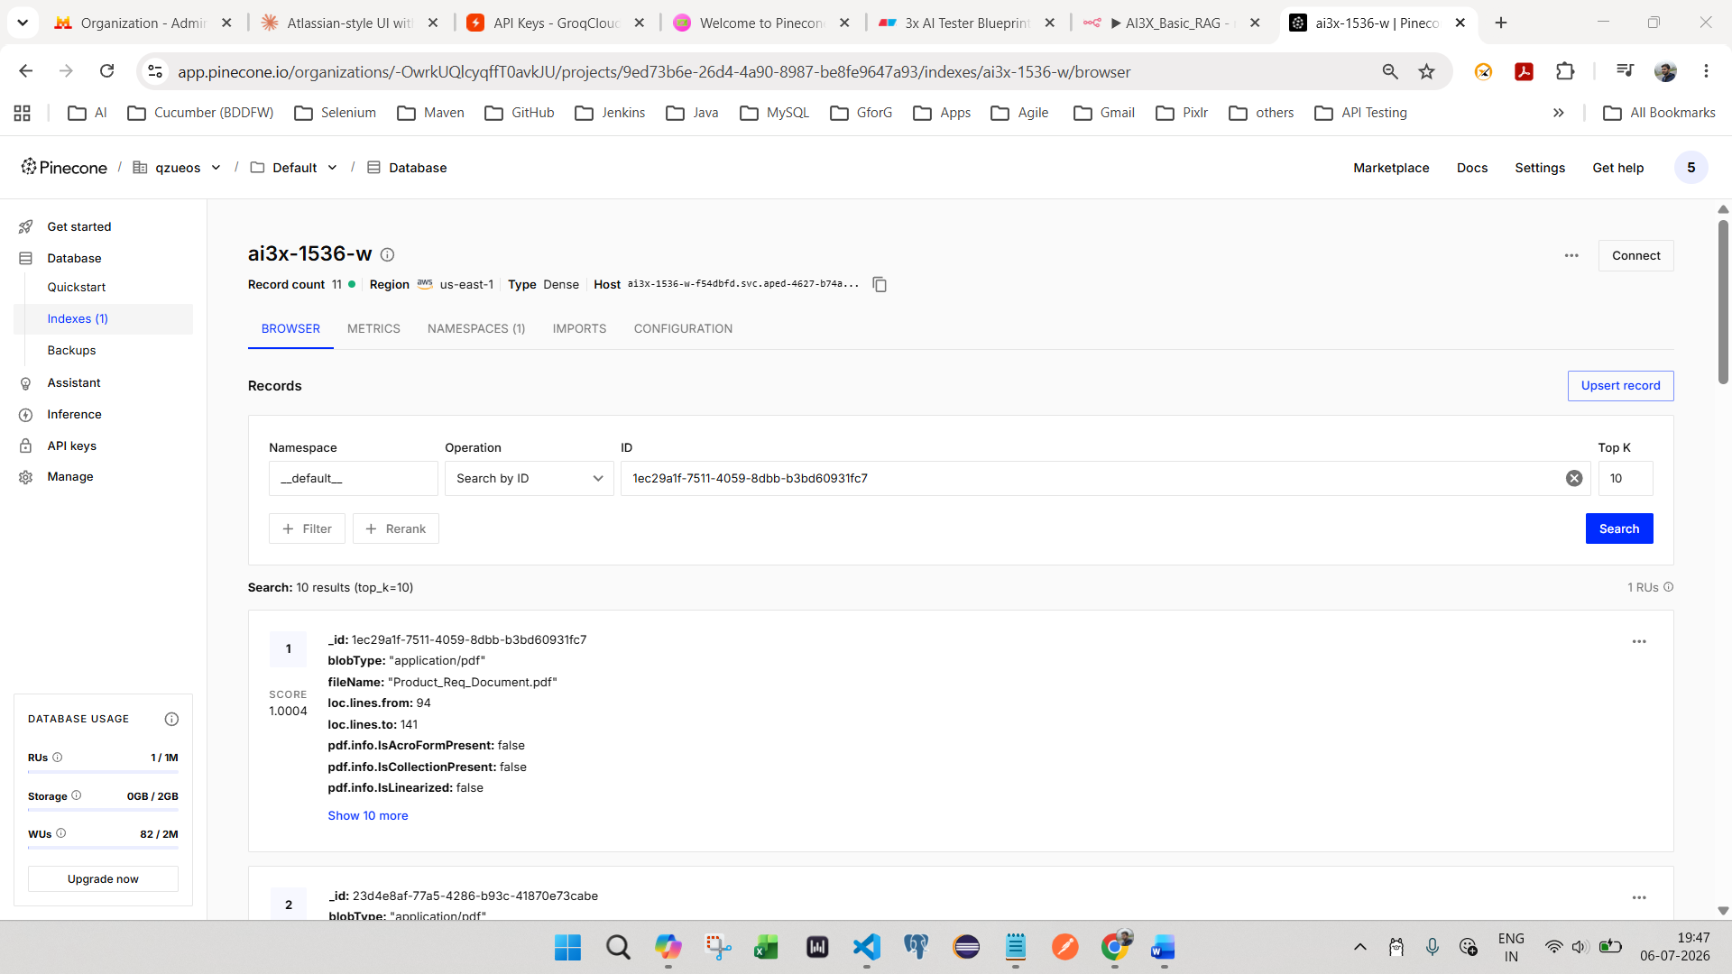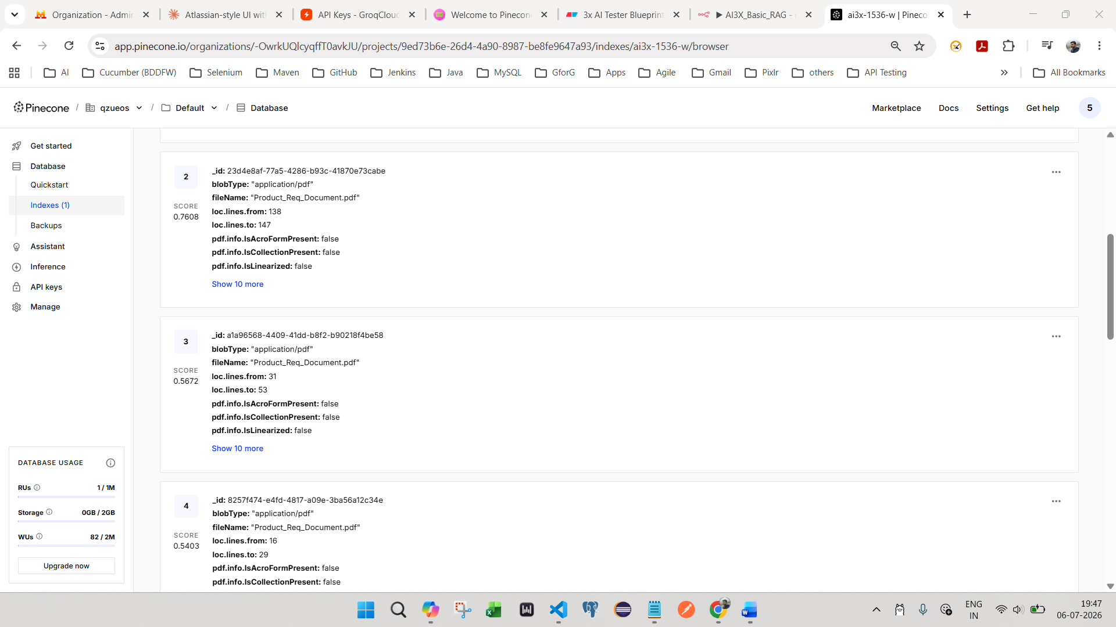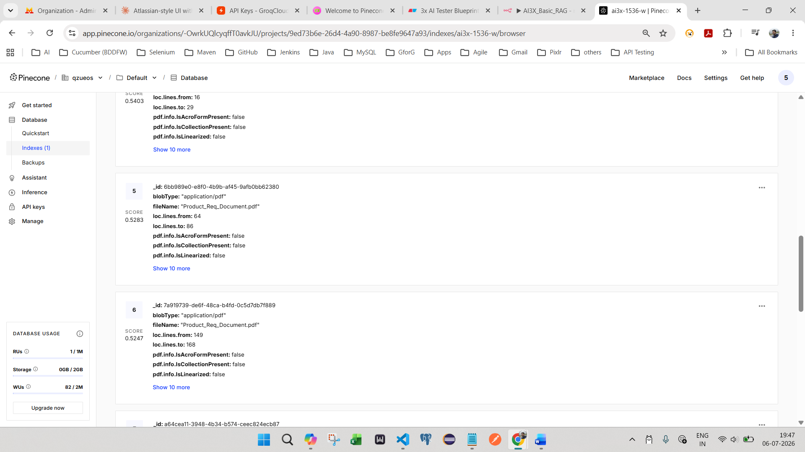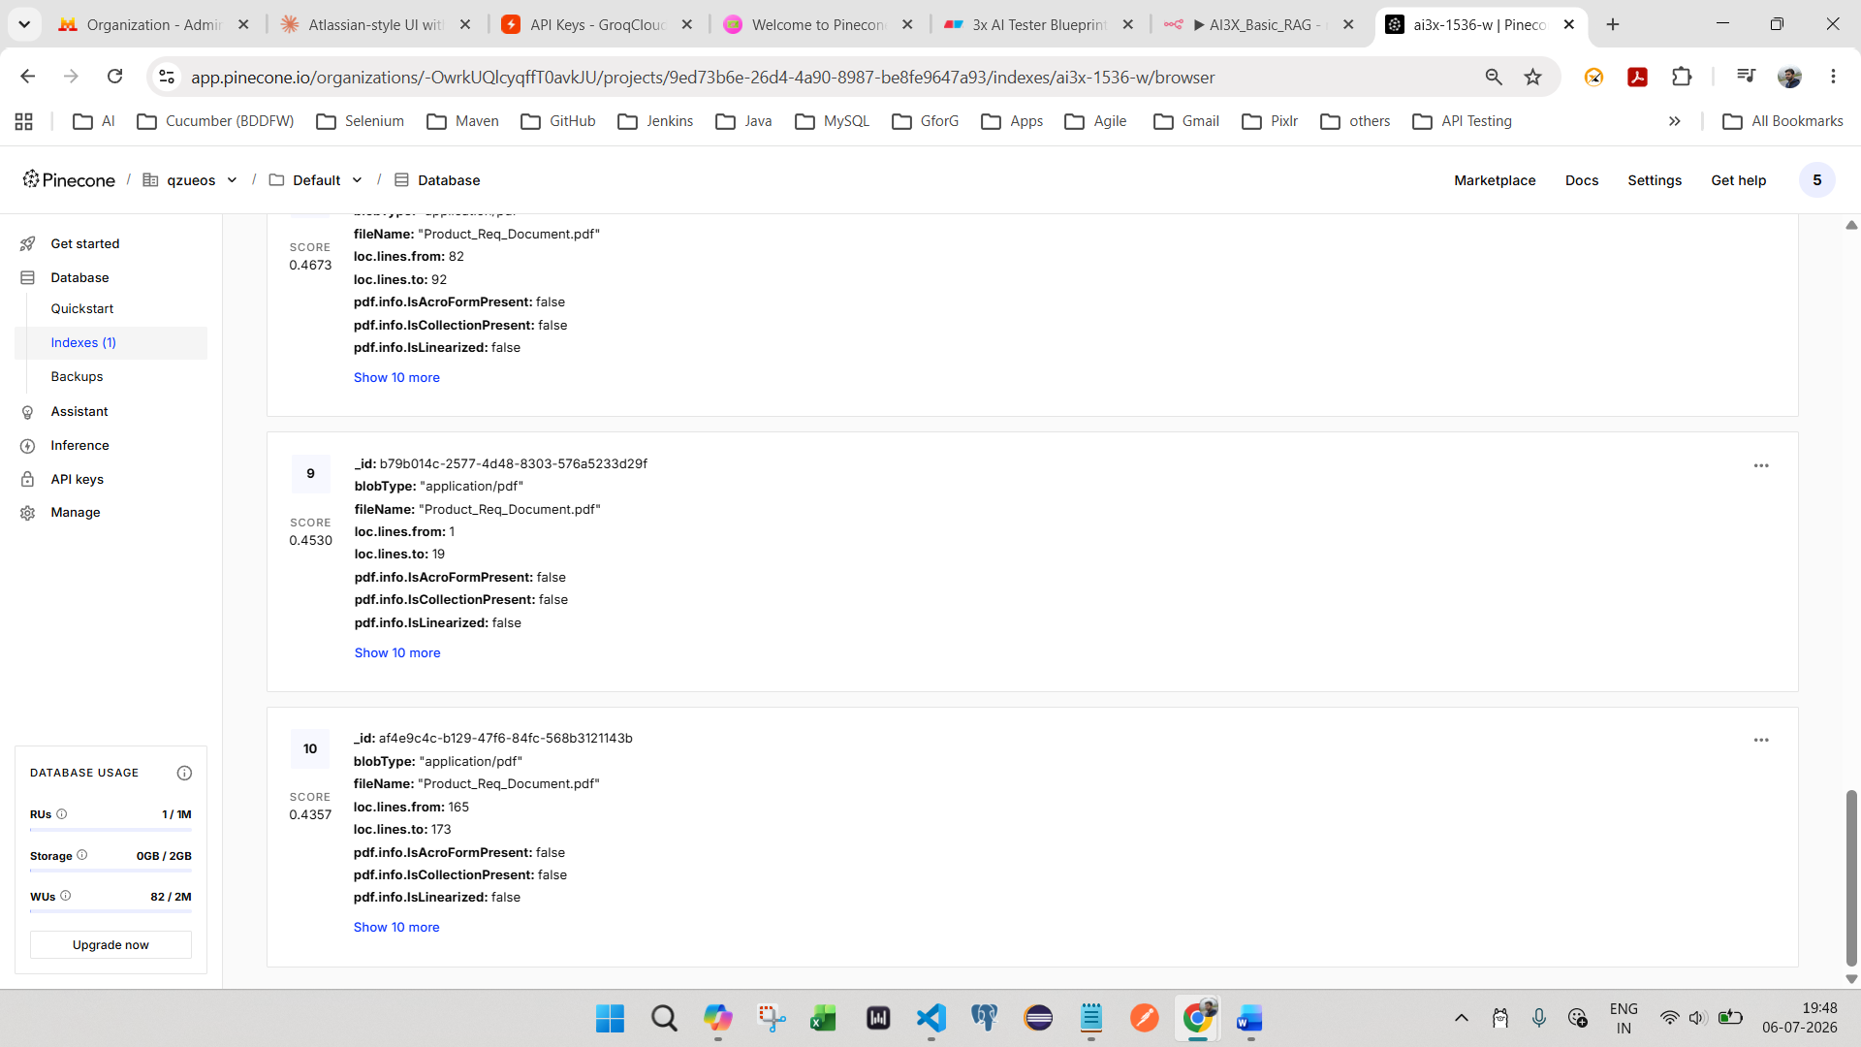
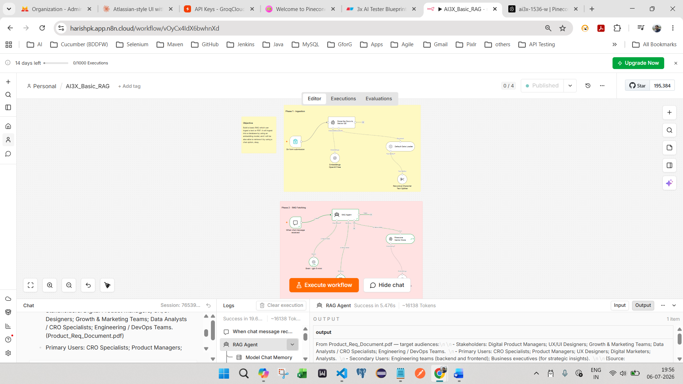
06 July to 20th July
efefuz5wg5@emailgenerator.xyz --same used for n8n

PINECODE API KEY
52e5sg4lbe@qzueos.com
ai3x-1536-w
pcsk_4Lhh67_DTwL3QWNAaLquAASDWmBw3aimZEcLfq7U3i8UVofTEwDnvTqu1KqbpqiX6fSbUX

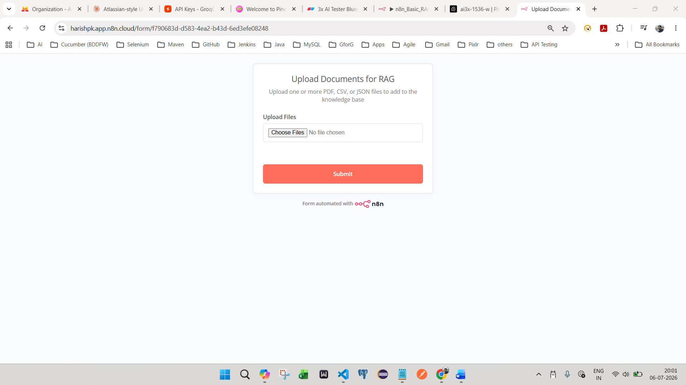https://harishpk.app.n8n.cloud/form/f790683d-d583-4ea2-b43d-6ed3efe08248
